

**Project Overview**

Software Engineering

Group 6

Table of Contents

The project 3

Domain model 4

User stories 5

Appendix 8

# The project

We were set out to make a functional system servicing a sharing economy. In a sharing economy peers acquire, provide and share goods and services. The first idea we had as a group was to provide a service that enabled users to sell, buy, trade and rent various items. The items could be everything from simple household items up to bigger things for example apartments and vehicles. The user would be able to list items as well as approaching them to buy or rent.

Upon consulting with our product owner we reached the conclusion that our original idea was far too complex. We had already sketched our domain model, made scenarios and user stories. They can be found in the appendix. Although we had to do the same work all over again, the original idea was very useful. The process of polishing our idea and narrowing it down was extremely informative. We narrowed the scope to a simple marketplace where users would approach people offering cleaning services. Users could be looking to clean everything ranging from apartments to a banquet hall. The system would offer features as reviewing services after use. Reviews would be in the form of comments and ratings. Other user features would simply be ordering and providing services. Admin features would include looking at sales statistics, viewing reported users and deactivating users.

Stakeholders are

* Cleaning Providers
* People that want cleaning services
* SharingEco staff
* Legal Firms
* Financial Firms

# Domain model

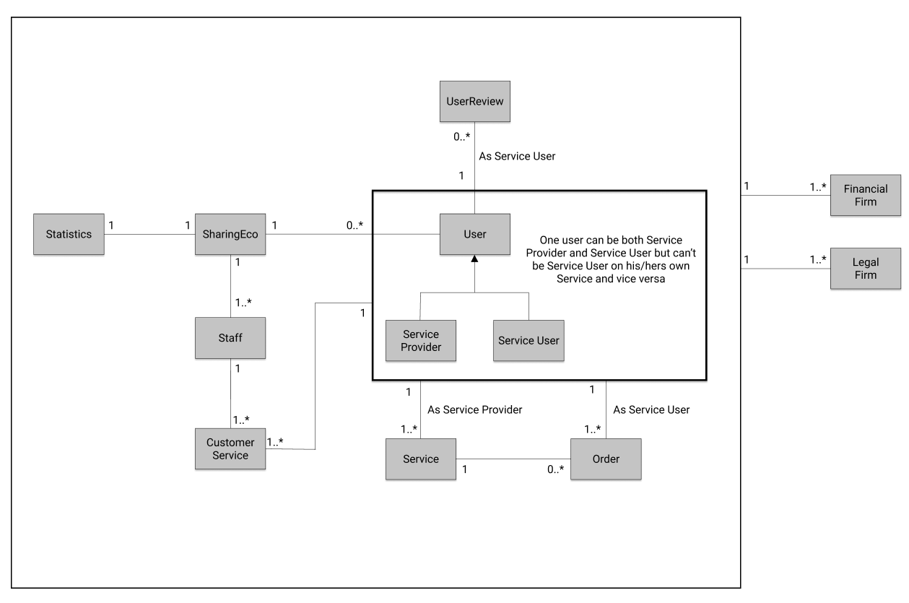

The domain is our product, the area of concern. The domain model is simply a visual representation of the objects in the system. Following objects are the inside parts of our system: statistics report, user, staff, service and order. Outside parts contain a financial firm and a legal firm. Handling of payments and bookkeeping is outsourced to the financial firm. The legal firm would handle the terms of service.

A single user could both be a provider of service and a buyer of service although the user can’t approach its own service, as represented in the black box. A single user can order or provide multiple services. The staff handles the daily business and takes care of customer service and statistics.

# User stories

**#1 User provides cleaning service**

Starting situation:

User has logged in to his/her account in SharingEco.

Normal event flow:

User selects from the main page the option “Advertise cleaning service”, and is transferred to a form where user inputs: 1) cleaning service provided, 2) date period for service availability, 3) rate per hour, 4) other must-known details. Afterwards, the user confirms his/her registration of service provided.

Alternative flow:

User selects from the main page the option “Profile page”, and is transferred to his/her personal user information page. Here, the user has the option to choose “Advertise cleaning service” and is then taken to the form page described in ‘Normal event flow’.

Other concurrent activities:

The system creates a cleaning service advertisement in SharingEco and is ready to be ordered by other users.

State when the scenario finishes:

User gets confirmation that the advertisement has been created by taking the user to his/her advertisement page in the system. Also, in his/her profile page is updated what service the user has ordered and/or is providing.

**#2 User orders cleaning service**

Starting situation:

User has logged in to his/her account in SharingEco.

Normal event flow:

User uses the search bar from the main page, where he/she provides a given date when cleaning service is needed. The user is then taken to the page where cleaning services are listed up for the given date provided. When user has found a service provider of his/her liking, the service is confirmed by giving the user credit card information. When this is done, and credit card information has been validated for payment, the user gets confirmation for booking of service.

Alternative flow:

The user selects from the main page an advertisement of a service provider, and if the advertisement is off his/her liking, follows the same steps in the later stages given under ‘Normal event flow’.

Other concurrent activities:

The system notifies the cleaning provider that his/her service is ordered for the specified date.

State when the scenario finishes:

User retrieves the final confirmation via email message and on his/her profile page the ordered service is shown.

**#3 User gives review on service**

Starting situation:

User has logged in to his/her account in SharingEco.

Normal event flow:

User select ‘Profile page’ from the main page of the system, and is transferred to the personal site of the user where information about the user is given and his/her service order history. Here, the user can then choose a service he/she has previously ordered and give a star rating from 1 to 5 for the service, as well as given a comment about the reason behind the star rating given.

Alternative flow:

No alternative flow for this particular future.

Other concurrent activities:

The system updates the star rating according to the newly given star rating.

State when the scenario finishes:

The average star rating of the service provider is updated in the system, with star rating and comments given by the service user.

**#4 Admin checks the sales statistics in system**

Starting situation:

Staff member has logged in to his/her admin account in SharingEco.

Normal event flow:

Admin selects the option “Statistics” from the main page. When selected, the admin is given information about sales statistics in accordance to sales orders.

Alternative flow:

No alternative flow for this particular future.

Other concurrent activities:

None.

State when the scenario finishes:

User has all the statistics needed about sales revenue/loss.

**#5 Admin deactivates reported user**

Starting situation:

Admin has logged in to his/her admin account in SharingEco.

Normal event flow:

Admin selects the option “Reported Users” from the main page. When selected, the admin is given the list of reported users and clicks de-activate next to their name.

Alternative flow:

No alternative flow for this particular future.

Other concurrent activities:

None.

State when the scenario finishes:

User account has been deactivated in the system and his/her advertisements get deleted and their orders cancelled.

# Appendix

**Original domain model**

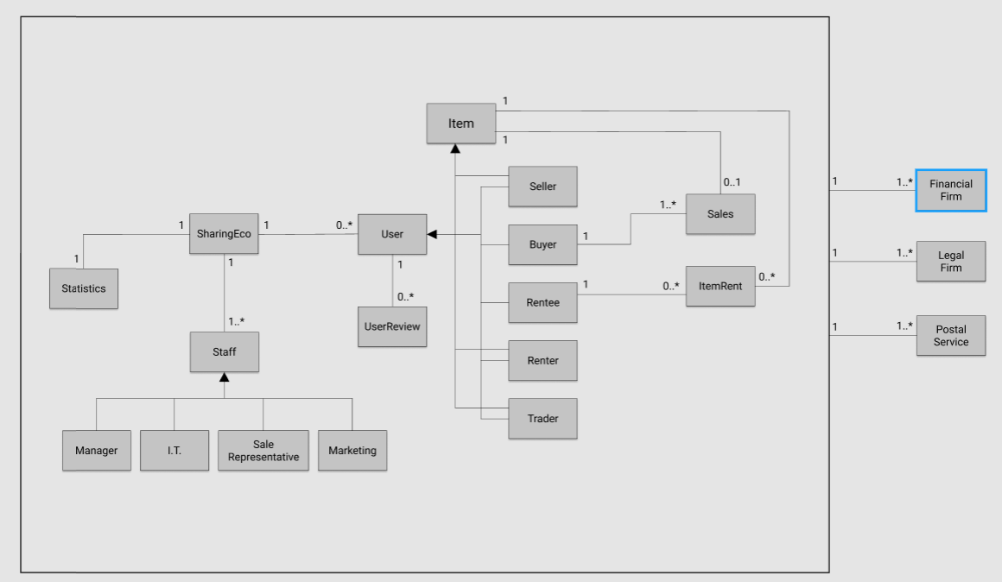

**Original user scenarios**

**#1 User rents an apartment/house**

Starting situation:

User wants to rent a house in Florida, and logs into his/her account for SharingEco.

Normal event flow:

The user looks for apartments/houses that are for rent, by using the search bar – inputs the word „Florida“. The user gets back all the housing that has been put for rent in Florida, USA. The user then chooses the housing of his/her liking, and confirms the rent of the house for a particular period in time. He / She then puts in his/her credit card information and confirms the payment.

Alternative flow:

1. The user has chosen a house of his/her liking, but does not accept the amount that is put for the rent of the house. Instead, he/she puts into the search bar again the place he/she wants to see housings for rent in a specific area.
2. The user decides on another place to visit, and searches therefore for this new location by inputting the name into the search bar.
3. The user does not like any of the housing that is for rent in Florida, and therefore decides to wait for more houses to be put for rent at a later stage.

Other concurrent activities:

………….

State when the scenario finishes:

The user has rented a real estate in Florida for a specific period, and got in an email the confirmation of payment with the information about the house rented and the date of rent.

**#2 User wants to trade his apartment for another in Copenhagen**

Starting situation:

User is logged into his/her account in SharingEco.

Normal event flow:

User inputs the location he/she wants an apartment, and the time period (date) of rent – for example in Copenhagen between 20.-23 August 2020. The user then gets all the real estates that are available for rent in the specified area for the date that was searched for. The user then chooses a real estate of his/her liking, and sends an inquiry with the information about his/her apartment he wants to trade for and the date of trade, to see if the other user wants to make a deal for trading apartments.

Alternative flow:

User wants to put his/her apartment for rent in August 2020 for four days, and is interested in any kind of trade for another apartment somewhere in the world. The user therefore chooses instead to go to his/her profile page and there chooses the option “Trade item”. There, the user needs to input all the necessary information about the apartment and the date(s) the apartment is available for rent. Afterwards, the user confirms the information that has been written and that the real estate in question is available for rent.

Other concurrent activities:

………….

State when the scenario finishes:

User has found another user (in Copenhagen) that is willing to trade apartments for the specified date.

**#3 User wants to buy a cheap lawn mower**

Starting situation:

User has logged into his/her account on SharingEco.

Normal event flow:

The user chooses the option “Items for sale”. The user is then taken to the site where all items that have been put for sale are listed up. Here the user then uses the search bar to get all the items of interest are listed – in this case a lawn mower. When a lawn mower has been found of his/her liking, the purchase is confirmed with given credit card information. After purchase has been confirmed, an email is sent to the user confirming the purchase and expected time of delivery for the item purchased.

Alternative flow:

The user puts in the search criteria “lawn mower” put there are no such items for sale found. The user can then either make another search request, for example “mower”, or look for other items for sale on the main site “Items for sale”.

Other concurrent activities:

………….

State when the scenario finishes:

The user is delivered his/her lawn mower that was purchased, and starts cutting the grass on his lawn.